Rectangular Dissection

Definition
# Source: AI Source: Provided by: [Data Path: Persons Table -> ID Column: 1, Name_En Column: Motasem Essam] -> From: [ChatGPT] on [7/25/2026]
Rectangular Dissection is a geometric dissection method in which a figure is divided into rectangular pieces that can be rearranged, joined, or compared to form another figure or demonstrate a geometric relationship.
The pieces may be congruent or noncongruent, and they may have equal or unequal areas. Rectangular dissection is especially useful for studying area equivalence, geometric rearrangements, and the relationships between different shapes.

Simple Definition
# Source: AI Source: Provided by: [Data Path: Persons Table -> ID Column: 1, Name_En Column: Motasem Essam] -> From: [ChatGPT] on [7/25/2026]
Rectangular Dissection is dividing a geometric figure into rectangular pieces that can be used to reconstruct the original figure or form another figure.
For example, an L-shaped region can be divided into two rectangles, which can then be rearranged to form a larger rectangle if their dimensions and arrangement permit it.
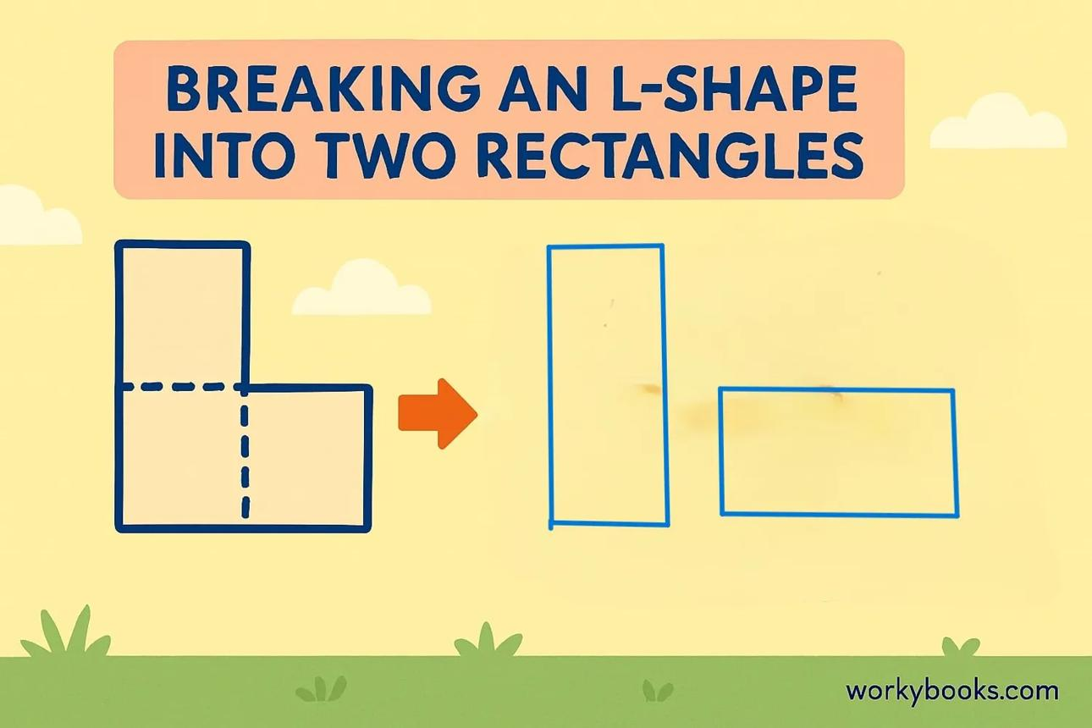
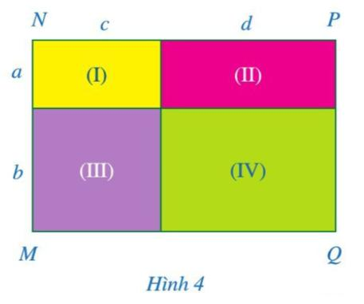
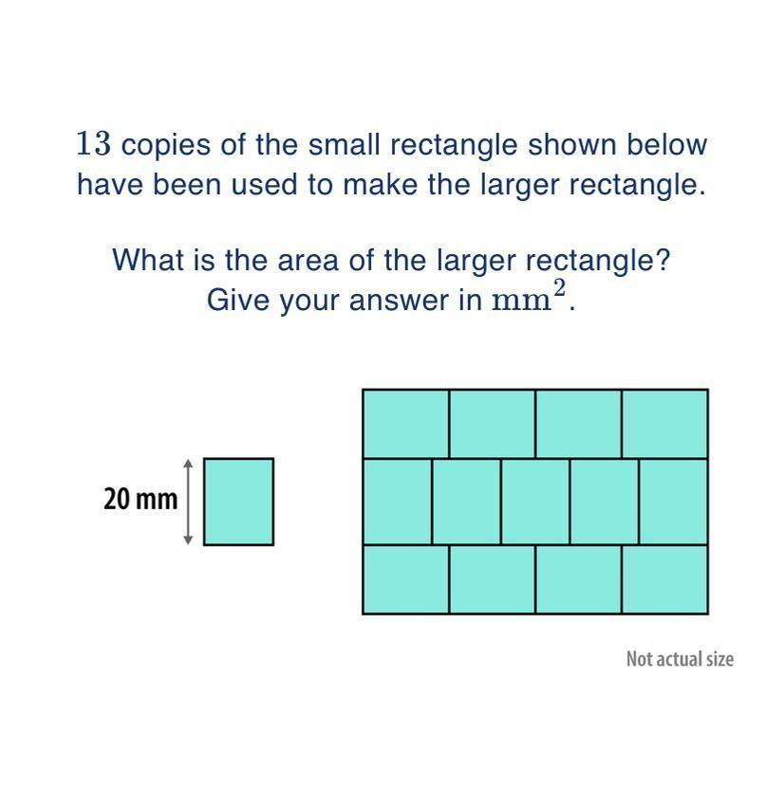
10
Important distinction:
- Rectangular decomposition focuses on dividing a figure into rectangles, often to simplify calculations.
- Rectangular dissection emphasizes the rectangular pieces and their use in rearrangement, reconstruction, or area-equivalence arguments.
The terms overlap in some geometry contexts. A rectangular dissection does not necessarily require rearrangement in every textbook or problem.

Main Classification
# Source: AI Source: Provided by: [Data Path: Persons Table -> ID Column: 1, Name_En Column: Motasem Essam] -> From: [ChatGPT] on [7/25/2026]
The following is a practical, descriptive classification, not a universally standardized mathematical taxonomy. Some categories overlap because a single dissection may use multiple methods.

1. Rectilinear-Figure Rectangular Dissection
# Source: AI Source: Provided by: [Data Path: Persons Table -> ID Column: 1, Name_En Column: Motasem Essam] -> From: [ChatGPT] on [7/25/2026]
Divides an L-shaped, stepped, or other rectilinear figure into rectangles.
Example: separating an L-shaped region into two rectangular pieces.
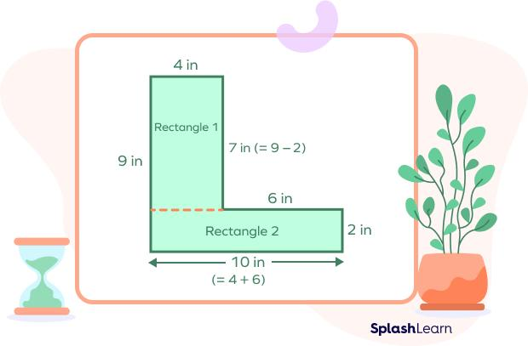
Detailed Explanation and Examples
Definition: A rectilinear figure is divided into rectangles using horizontal and vertical cuts. This method is useful for L-shaped, T-shaped, and stepped figures.
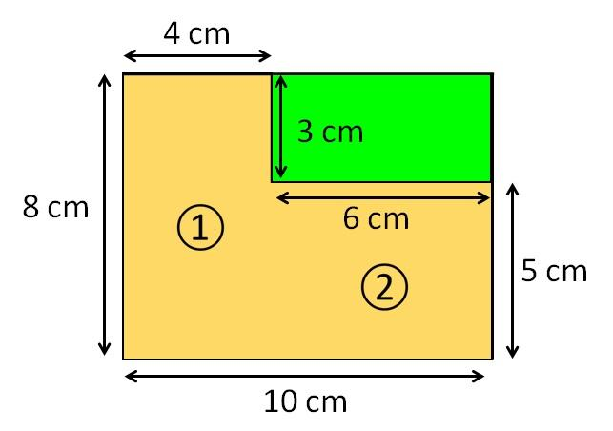
Example: An L-shaped figure is composed of two non-overlapping rectangles:
- Rectangle 1: $6×8$
- Rectangle 2: $4×3$
The total area is
$$A=6\left(8\right)+4\left(3\right)$$
$$\boxed{A=60}$$
The area is $60$ square units.
Important: The rectangular pieces must cover the original figure exactly, without gaps or overlapping interiors.

2. Grid-Based Rectangular Dissection
# Source: AI Source: Provided by: [Data Path: Persons Table -> ID Column: 1, Name_En Column: Motasem Essam] -> From: [ChatGPT] on [7/25/2026]
Divides a rectangle into smaller rectangular pieces using horizontal and vertical cuts.
Example: dividing a rectangle into six smaller rectangles of different dimensions.
Detailed Explanation and Examples
Definition: A rectangle is divided into smaller rectangles by drawing horizontal and vertical line segments.
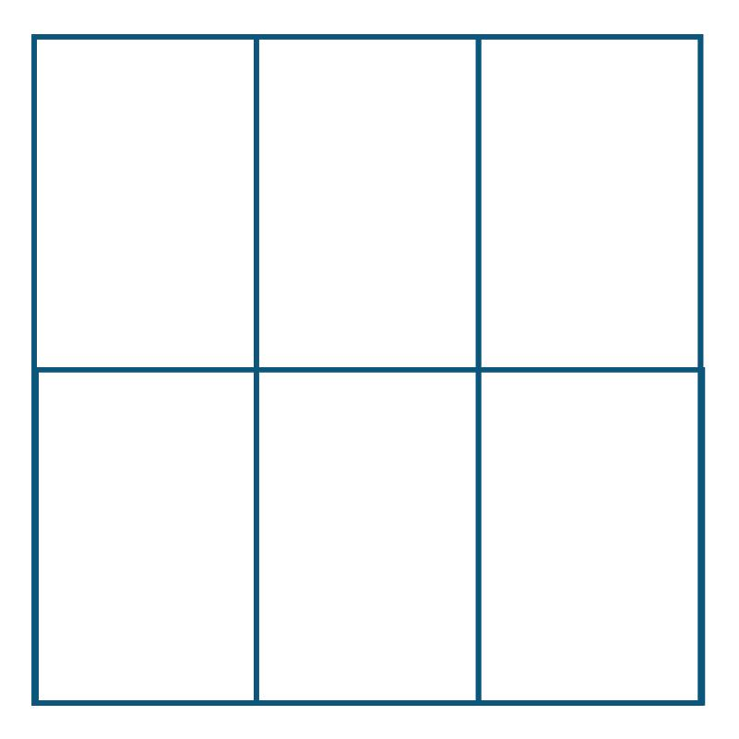
Example: A rectangle measuring $12×8$ units is divided into six rectangular pieces.
Suppose the three column widths are $3$, $4$, and $5$ units, while the two row heights are $3$ and $5$ units.
The areas of the six rectangles are:
$$9, 12, 15, 15, 20, 25$$
Their sum is
$$A=9+12+15+15+20+25=96$$
This equals the original area:
$$A=12\left(8\right)=96$$
Important: Grid-based rectangular dissection can produce pieces with equal or unequal areas, depending on the spacing of the cuts.

3. Congruent-Rectangle Dissection
# Source: AI Source: Provided by: [Data Path: Persons Table -> ID Column: 1, Name_En Column: Motasem Essam] -> From: [ChatGPT] on [7/25/2026]
Uses rectangular pieces that have identical dimensions and shapes.
Example: dividing a rectangle into four congruent smaller rectangles.
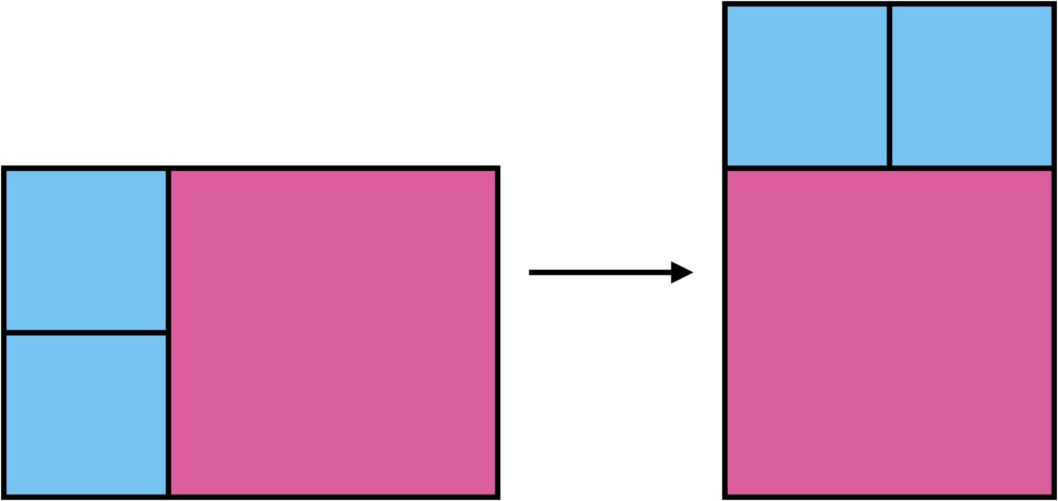
Detailed Explanation and Examples
Definition: A figure is divided into congruent rectangular pieces, meaning the pieces have identical dimensions and shapes.
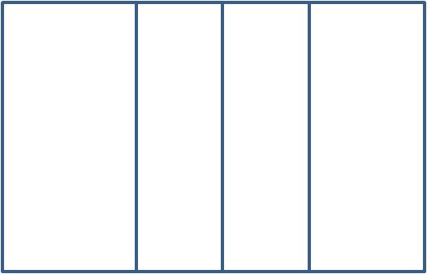
Example: A rectangle measuring $12×8$ units is divided into four congruent rectangles by dividing its length into four equal parts.
Each smaller rectangle measures $3×8$ units.
The area of each piece is
$$A_{\text{piece}}=3\left(8\right)=24$$
The total area is
$$A=4\left(24\right)=96$$
Important: Congruent rectangles necessarily have equal areas and perimeters, but a collection of equal-area rectangles need not be congruent.

4. Noncongruent-Rectangle Dissection
# Source: AI Source: Provided by: [Data Path: Persons Table -> ID Column: 1, Name_En Column: Motasem Essam] -> From: [ChatGPT] on [7/25/2026]
Uses rectangular pieces of different dimensions.
Example: dividing a $12×8$ rectangle into rectangles of different widths and heights.
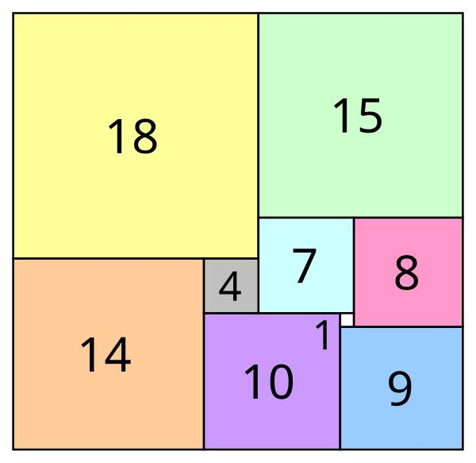
Detailed Explanation and Examples
Definition: A figure is divided into rectangular pieces of different dimensions.
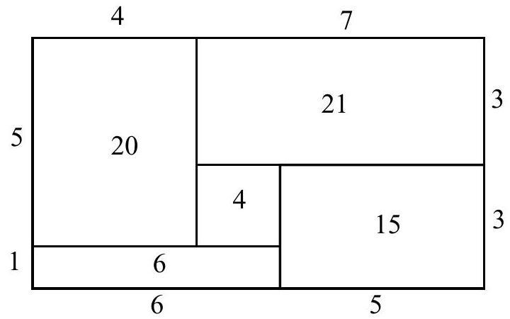
Example: A $12×8$ rectangle is divided into four rectangles with dimensions:
- $3×8$
- $4×8$
- $2×4$
- $3×4$
These dimensions can form a valid partition if the pieces are arranged to cover the original rectangle without gaps or overlaps. For example, the first two rectangles together occupy the full height and a width of $7$; the remaining width is $5$, which can be filled by the last two rectangles only if their placement and dimensions are adjusted accordingly.
For a simpler valid example, divide a $10×6$ rectangle into two vertical rectangles measuring $4×6$ and $6×6$.
Their areas are
$$A_{1}=4\left(6\right)=24, A_{2}=6\left(6\right)=36$$
Therefore,
$$A_{\text{total}}=24+36=60$$
Important: Different dimensions are allowed, but the arrangement must be geometrically consistent with the original figure.

5. Rearrangement-Based Rectangular Dissection
# Source: AI Source: Provided by: [Data Path: Persons Table -> ID Column: 1, Name_En Column: Motasem Essam] -> From: [ChatGPT] on [7/25/2026]
Moves or rotates rectangular pieces to construct another figure.
Example: rearranging rectangular pieces to form a rectangle with a different overall arrangement.
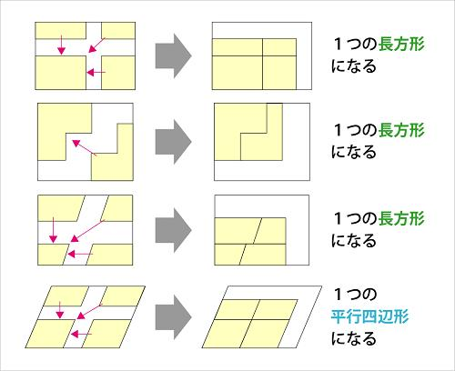
Detailed Explanation and Examples
Definition: Rectangular pieces are moved or rotated to form another arrangement while preserving each piece's dimensions and area.
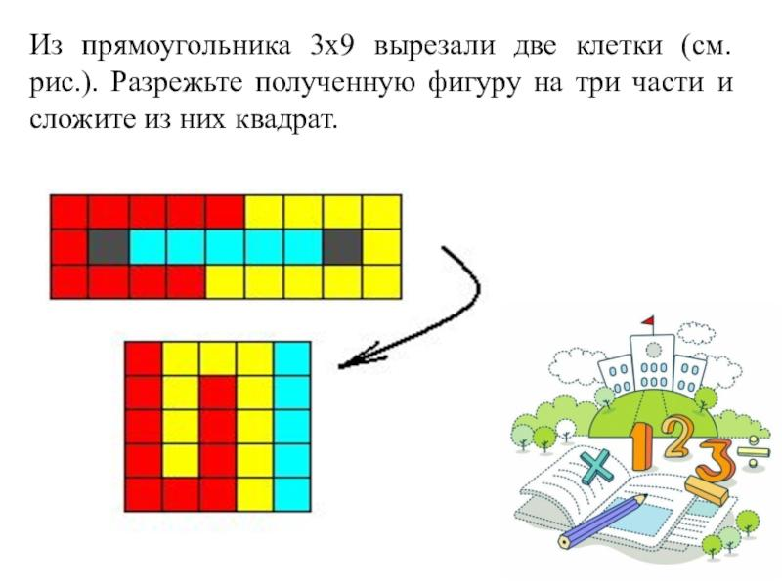
Example: A $12×4$ rectangle is divided into four $3×4$ rectangles.
The original area is
$$A=12\left(4\right)=48$$
Arrange the four pieces in two rows and two columns, keeping each piece in the same orientation. The resulting rectangle measures $6×8$.
Its area is
$$A=6\left(8\right)=48$$
The total area is preserved.
Important: A valid rearrangement preserves the pieces themselves. Their interiors must not overlap, and together they must cover the resulting figure.

6. Square-to-Rectangle Dissection
# Source: AI Source: Provided by: [Data Path: Persons Table -> ID Column: 1, Name_En Column: Motasem Essam] -> From: [ChatGPT] on [7/25/2026]
Uses rectangular pieces to transform a square into a rectangle or vice versa.
Example: cutting a square into rectangular strips and rearranging them into a rectangle of equal area.
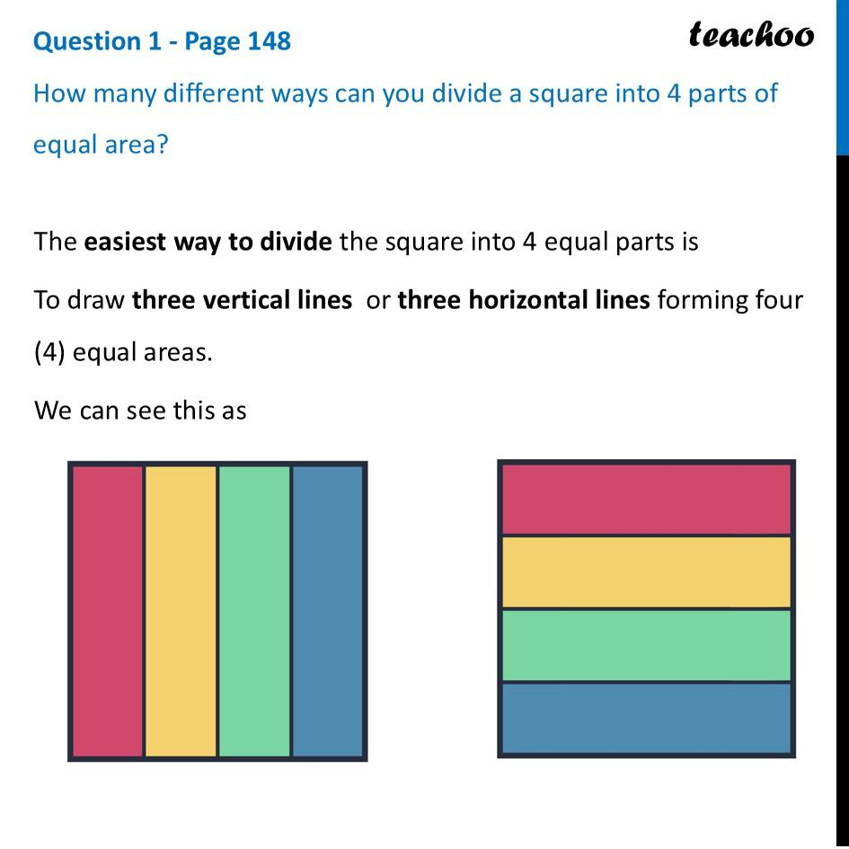
Detailed Explanation and Examples
Definition: A square is divided into rectangular pieces that are rearranged to form a rectangle of different dimensions but equal area.
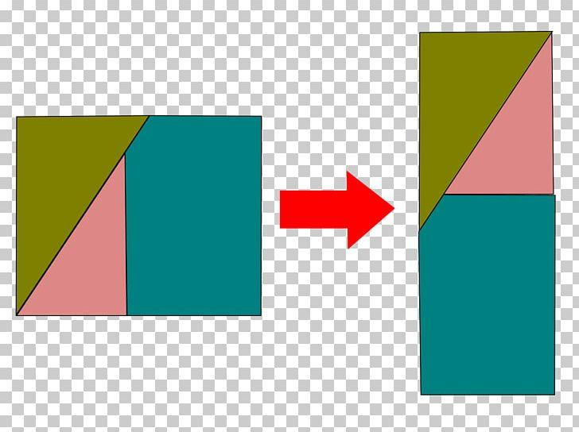
Example: A square of side length $8$ units is divided into four rectangular strips, each measuring $8×2$ units.
The square's area is
$$A=8^{2}=64$$
Each strip has area
$$A_{\text{strip}}=8\left(2\right)=16$$
If the strips are rearranged into a $16×4$ rectangle, the area is
$$A=16\left(4\right)=64$$
Both figures have area $64$ square units.
Important: The dimensions of the resulting rectangle must be compatible with the exact pieces. Equal area by itself does not guarantee that a particular dissection exists.

7. Rectangle-to-Rectangle Dissection
# Source: AI Source: Provided by: [Data Path: Persons Table -> ID Column: 1, Name_En Column: Motasem Essam] -> From: [ChatGPT] on [7/25/2026]
Divides one rectangle into rectangular pieces that can be reassembled into a rectangle with different dimensions.
Example: transforming a $12×4$ rectangle into a $6×8$ rectangle using an appropriate rectangular tiling.
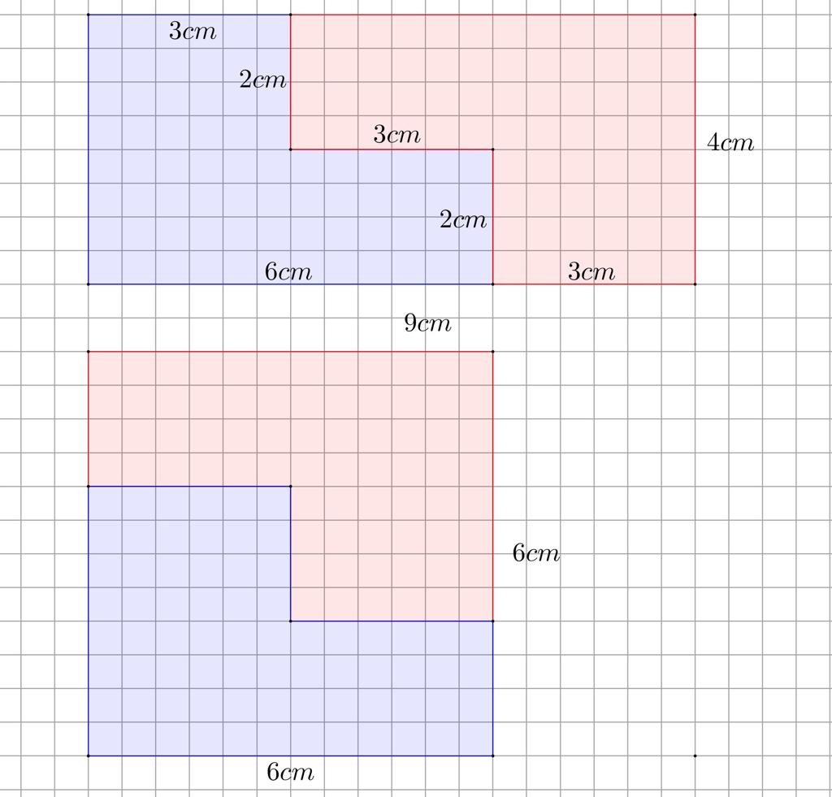
Detailed Explanation and Examples
Definition: One rectangle is divided into rectangular pieces that are rearranged into another rectangle with different dimensions.
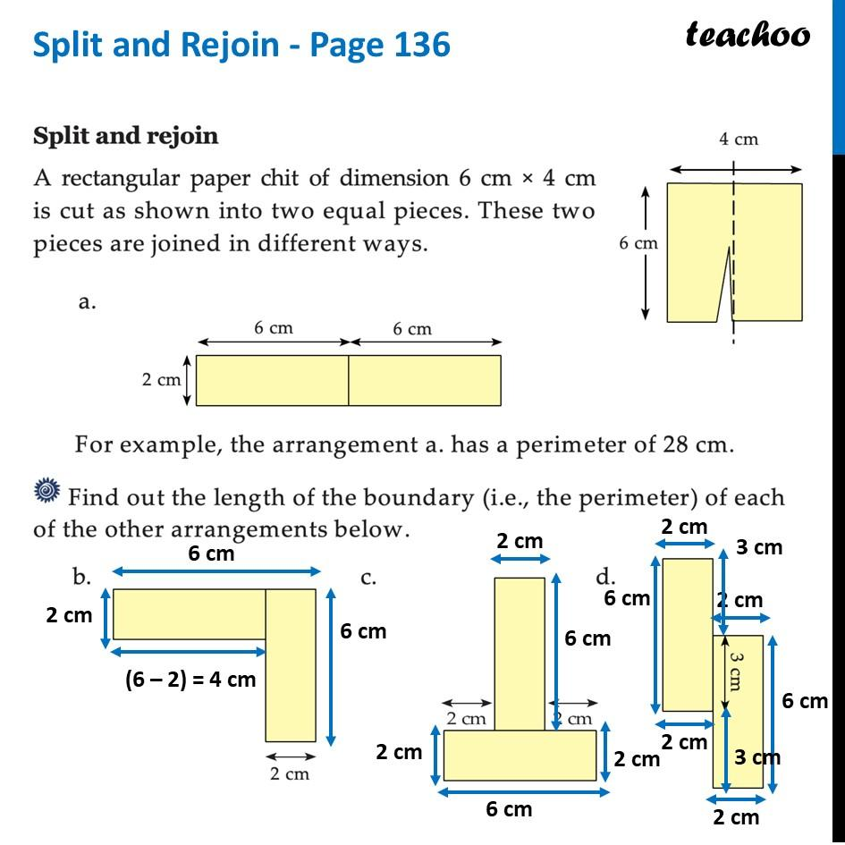
Example: Transform a $12×4$ rectangle into a $6×8$ rectangle.
Divide the original rectangle into four $3×4$ rectangles. Arrange them in two rows and two columns.
Original area:
$$A_{1}=12\left(4\right)=48$$
New area:
$$A_{2}=6\left(8\right)=48$$
Therefore,
$$\boxed{A_{1}=A_{2}}$$
Important: Rectangular dissections are useful for demonstrating area equivalence between rectangles with different proportions.

8. Multi-Rectangle Dissection
# Source: AI Source: Provided by: [Data Path: Persons Table -> ID Column: 1, Name_En Column: Motasem Essam] -> From: [ChatGPT] on [7/25/2026]
Uses several rectangular pieces to dissect a more complex polygonal figure.
Example: dividing a stepped polygon into three or more rectangles.
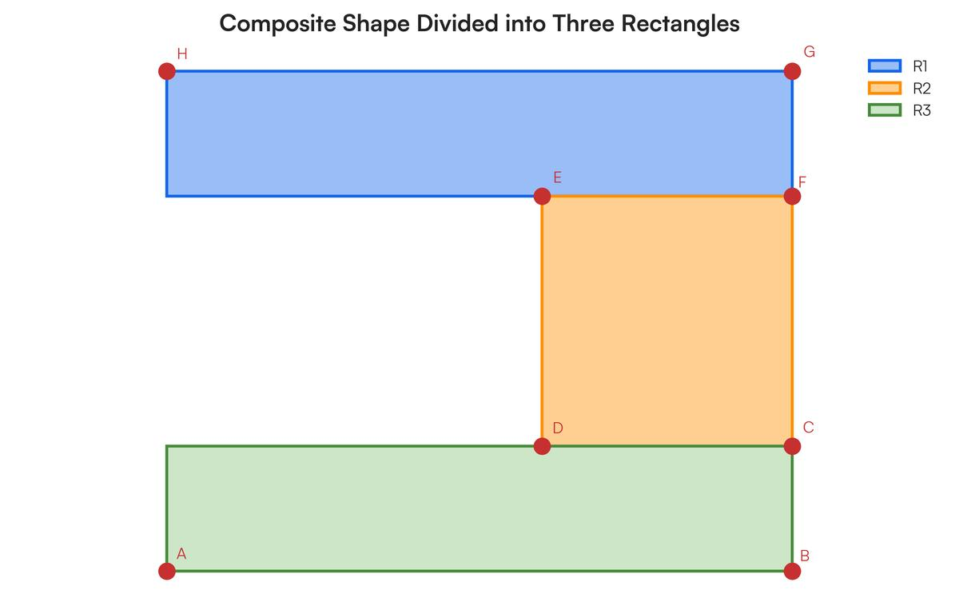
Detailed Explanation and Examples
Definition: A complex figure is divided into three or more rectangular pieces, potentially with different dimensions.
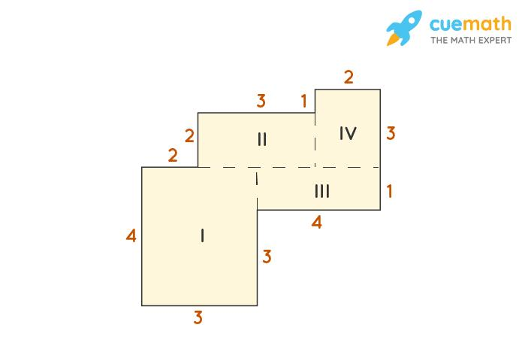
Example: A stepped figure is composed of three non-overlapping rectangles:
- Rectangle 1: $6×4$
- Rectangle 2: $3×4$
- Rectangle 3: $3×2$
The total area is
$$A=6\left(4\right)+3\left(4\right)+3\left(2\right)$$
$$A=24+12+6$$
$$\boxed{A=42}$$
The figure's area is $42$ square units.
Important: Multi-rectangle dissection is useful when a complex rectilinear figure cannot conveniently be handled as a single rectangle.

9. Area-Equivalence Rectangular Dissection
# Source: AI Source: Provided by: [Data Path: Persons Table -> ID Column: 1, Name_En Column: Motasem Essam] -> From: [ChatGPT] on [7/25/2026]
Uses rectangular pieces to demonstrate that two figures have the same total area.
Example: assembling the same rectangular pieces into two different rectangular arrangements.
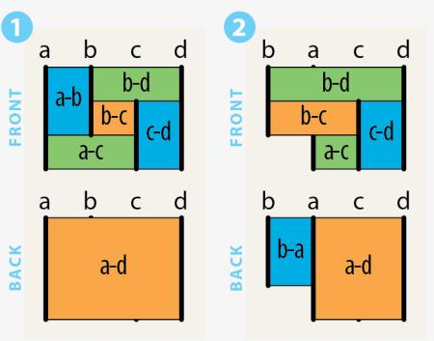
Detailed Explanation and Examples
Definition: Rectangular pieces are used to establish that two figures have equal areas by showing that both can be assembled from the same pieces.
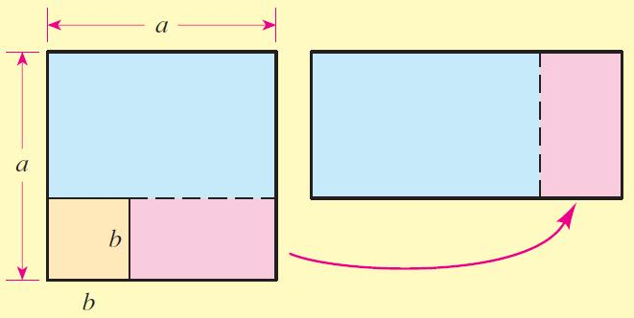
Example: A $10×6$ rectangle has area
$$A=10\left(6\right)=60$$
Divide it into two rectangles measuring $4×6$ and $6×6$.
Their areas are
$$A_{1}=24, A_{2}=36$$
The total is
$$A_{1}+A_{2}=60$$
If these same pieces are rearranged without gaps or overlaps, the resulting figure also has area $60$ square units.
Important: Equal area does not necessarily mean equal perimeter or congruent overall shapes.

10. Multi-Stage Rectangular Dissection
# Source: AI Source: Provided by: [Data Path: Persons Table -> ID Column: 1, Name_En Column: Motasem Essam] -> From: [ChatGPT] on [7/25/2026]
Repeatedly subdivides rectangular pieces into smaller rectangles.
Example: dividing a rectangle into four pieces, then subdividing one of those pieces into four smaller rectangles.

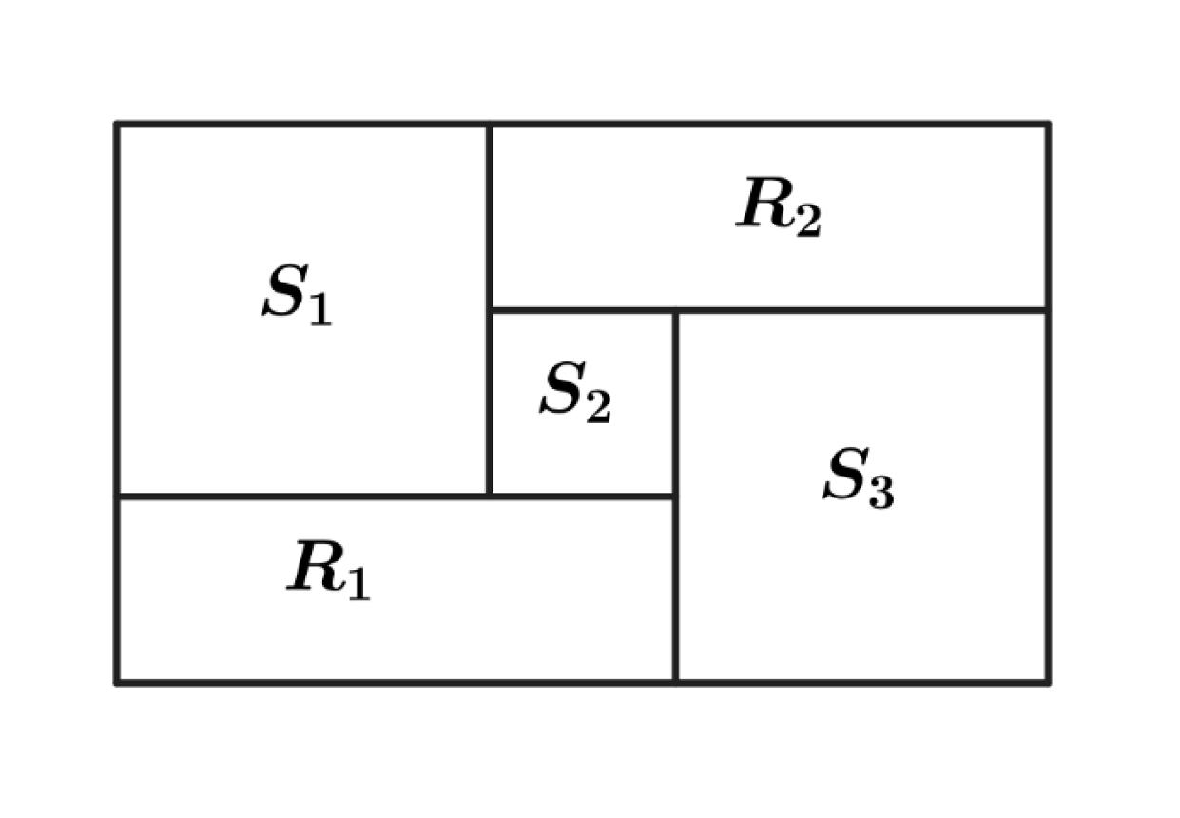
Detailed Explanation and Examples
Definition: Rectangular pieces are subdivided repeatedly into smaller rectangles.
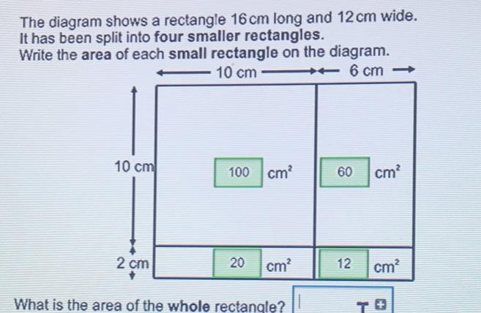
Example: A $12×8$ rectangle has area
$$A=12\left(8\right)=96$$
First, divide it into four rectangles of equal dimensions, each measuring $6×4$.
Each piece has area
$$A_{1}=6\left(4\right)=24$$
Then subdivide one of these pieces into four rectangles measuring $3×2$.
Each new small rectangle has area
$$A_{2}=3\left(2\right)=6$$
The final partition consists of three unchanged rectangles of area $24$ and four smaller rectangles of area $6$.
Verification:
$$3\left(24\right)+4\left(6\right)=72+24=96$$
The total area remains $96$ square units.
Important: Repeated subdivision increases the number of pieces without changing the original figure's total area, provided the pieces form an exact partition.

Key Formulas
# Source: AI Source: Provided by: [Data Path: Persons Table -> ID Column: 1, Name_En Column: Motasem Essam] -> From: [ChatGPT] on [7/25/2026]
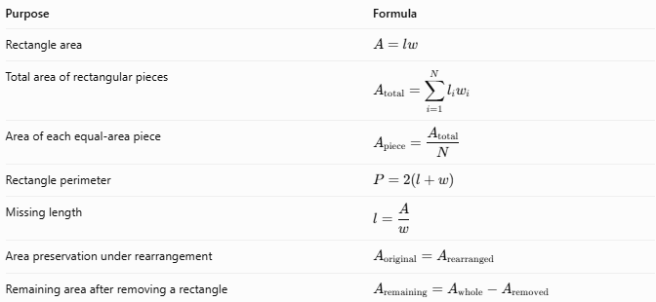
Purpose | Formula
Rectangle area | $$A=lw$$
Total area of rectangular pieces | $$A_{\text{total}}=\sum_{i=1}^{N}{l_{i}}w_{i}$$
Area of each equal-area piece | $$A_{\text{piece}}=\frac{A_{\text{total}}}{N}$$
Rectangle perimeter | $$P=2\left(l+w\right)$$
Missing length | $$l=\frac{A}{w}$$
Area preservation under rearrangement | $$A_{\text{original}}=A_{\text{rearranged}}$$
Remaining area after removing a rectangle | $$A_{\text{remaining}}=A_{\text{whole}}-A_{\text{removed}}$$
Here, $l_{i}$ and $w_{i}$ are the length and width of the $i$-th rectangular piece, and $N$ is the number of pieces.

Comparison with Other Dissection Types
# Source: AI Source: Provided by: [Data Path: Persons Table -> ID Column: 1, Name_En Column: Motasem Essam] -> From: [ChatGPT] on [7/25/2026]
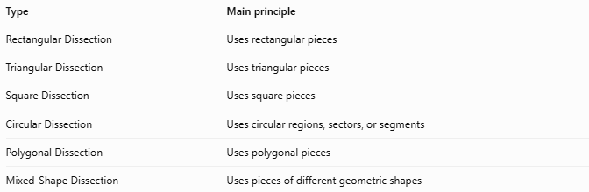
Type | Main principle
Rectangular Dissection | Uses rectangular pieces
Triangular Dissection | Uses triangular pieces
Square Dissection | Uses square pieces
Circular Dissection | Uses circular regions, sectors, or segments
Polygonal Dissection | Uses polygonal pieces
Mixed-Shape Dissection | Uses pieces of different geometric shapes
These categories can overlap. For example, a square can be dissected into rectangles, so a square-to-rectangle dissection is also a rectangular dissection.

Classification Summary
# Source: AI Source: Provided by: [Data Path: Persons Table -> ID Column: 1, Name_En Column: Motasem Essam] -> From: [ChatGPT] on [7/25/2026]
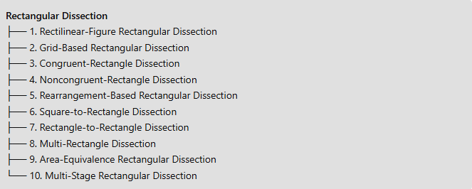
Rectangular Dissection
├── 1. Rectilinear-Figure Rectangular Dissection
├── 2. Grid-Based Rectangular Dissection
├── 3. Congruent-Rectangle Dissection
├── 4. Noncongruent-Rectangle Dissection
├── 5. Rearrangement-Based Rectangular Dissection
├── 6. Square-to-Rectangle Dissection
├── 7. Rectangle-to-Rectangle Dissection
├── 8. Multi-Rectangle Dissection
├── 9. Area-Equivalence Rectangular Dissection
└── 10. Multi-Stage Rectangular Dissection

Key Points
# Source: AI Source: Provided by: [Data Path: Persons Table -> ID Column: 1, Name_En Column: Motasem Essam] -> From: [ChatGPT] on [7/25/2026]
- Rectangular dissection uses rectangles as the pieces of a geometric dissection.
- Pieces may be congruent or noncongruent and may have equal or unequal areas.
- Rearrangement preserves total area when every piece is retained and no gaps or overlapping interiors are introduced.
- Rectangular pieces are particularly useful for dissecting L-shaped, stepped, and other rectilinear figures.
- A valid dissection requires geometrically compatible piece dimensions and placements.
- The classification above is practical and descriptive; several categories may apply to the same example.

Conclusion
# Source: AI Source: Provided by: [Data Path: Persons Table -> ID Column: 1, Name_En Column: Motasem Essam] -> From: [ChatGPT] on [7/25/2026]
Rectangular Dissection is a geometric method that uses rectangular pieces to divide, rearrange, reconstruct, or compare figures. Its practical types include grid-based, congruent-rectangle, noncongruent-rectangle, rearrangement-based, square-to-rectangle, rectangle-to-rectangle, and multi-stage dissections. It is especially useful for area-equivalence arguments, geometric puzzles, and the study of how figures can be transformed by rearranging pieces without changing their total area.

